**Lab 12: Capturing a RAM Image**

**Course Name**: Malware Analysis and Reverse Engineering (IAM302)

**Student Name**: Nguyễn Trần Vinh – SE160258

**Instructor Name**: Mai Hoàng Đỉnh

**Lab Due Date**: 25/2/2023

**Purpose**

* To save all information on the RAM of the Windows Server 2008 machine and use the Kali machine for analysis.

**What we need**

* The Windows Server 2008 virtual machine you prepared in the previous project. If you don't have it, you could use any Windows machine, real or virtual.
* Kali machine to analysis

**Step by step**

- Window + R -> cmd -> bcdedit /copy {current} /d "Low-Memory"

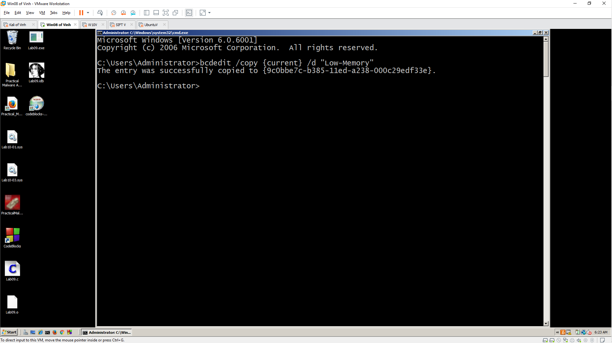

- bcdedit /set {9c0bbe7c-b385-11ed-a238-000c29edf33e} truncatememory 0x20000000

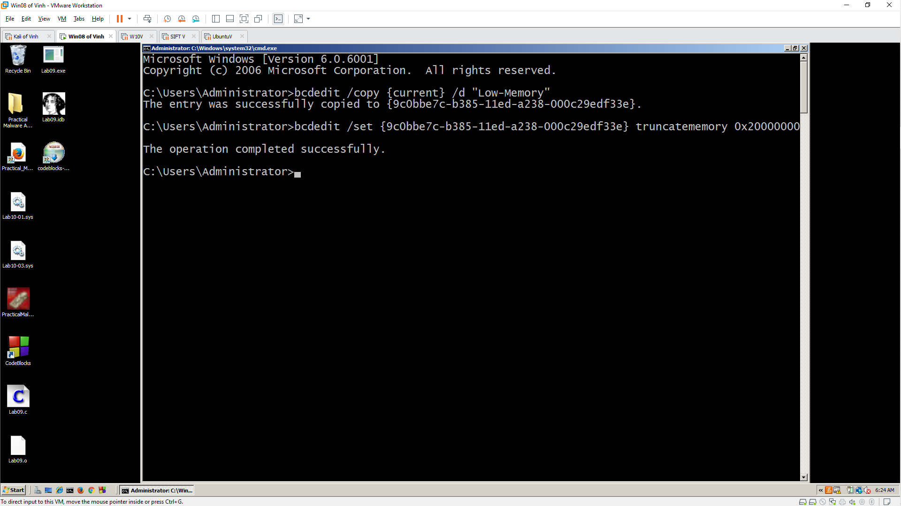

- bcdedit

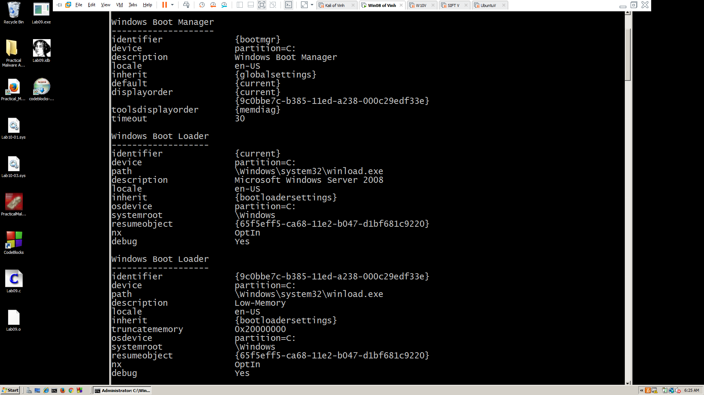

- restart machine

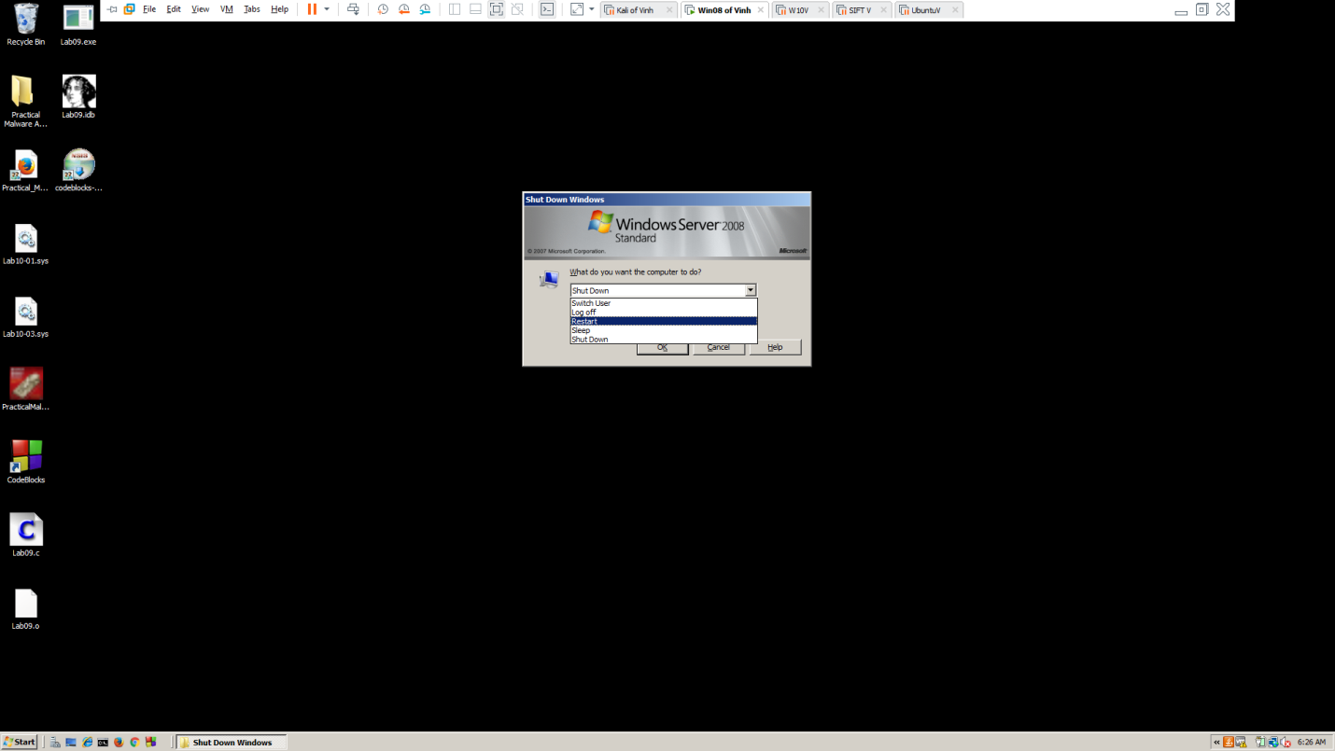

- low-memory

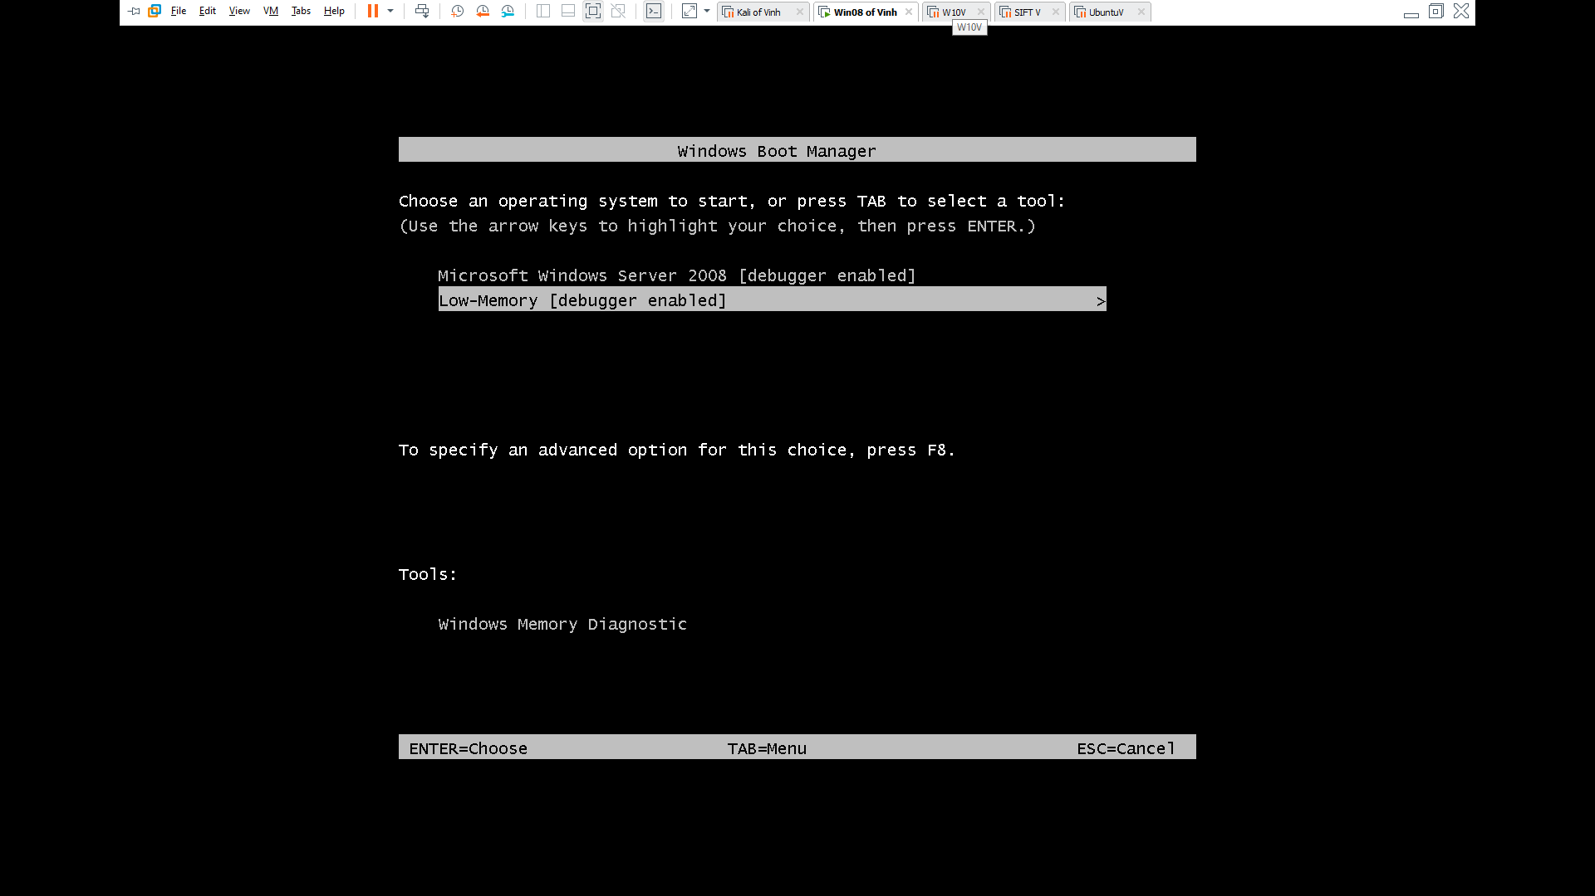

- Creating Evidence

* Download FTK Imager Lite version 3.1.2

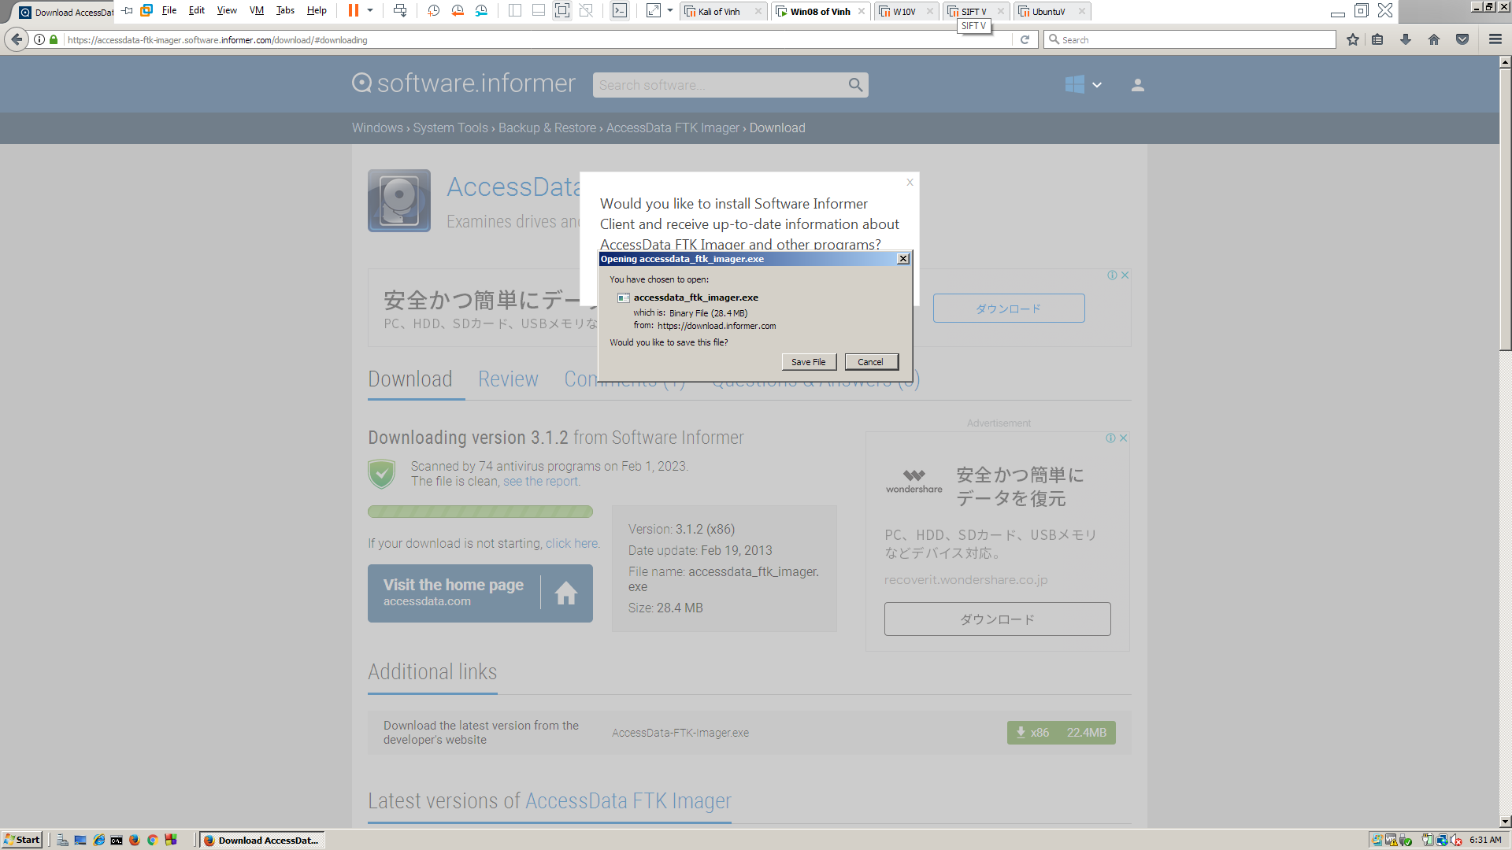

* Visit webiste:

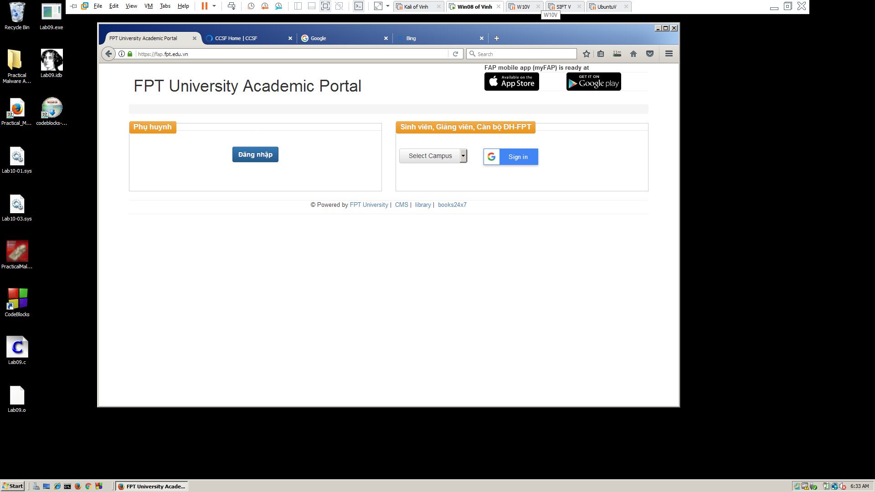

* Search “**fake credit card numbers**”

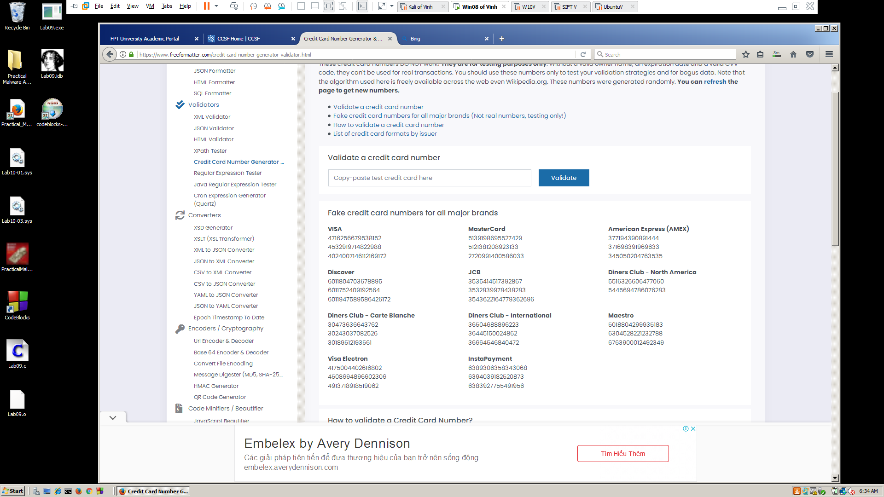

* Copy to notepad

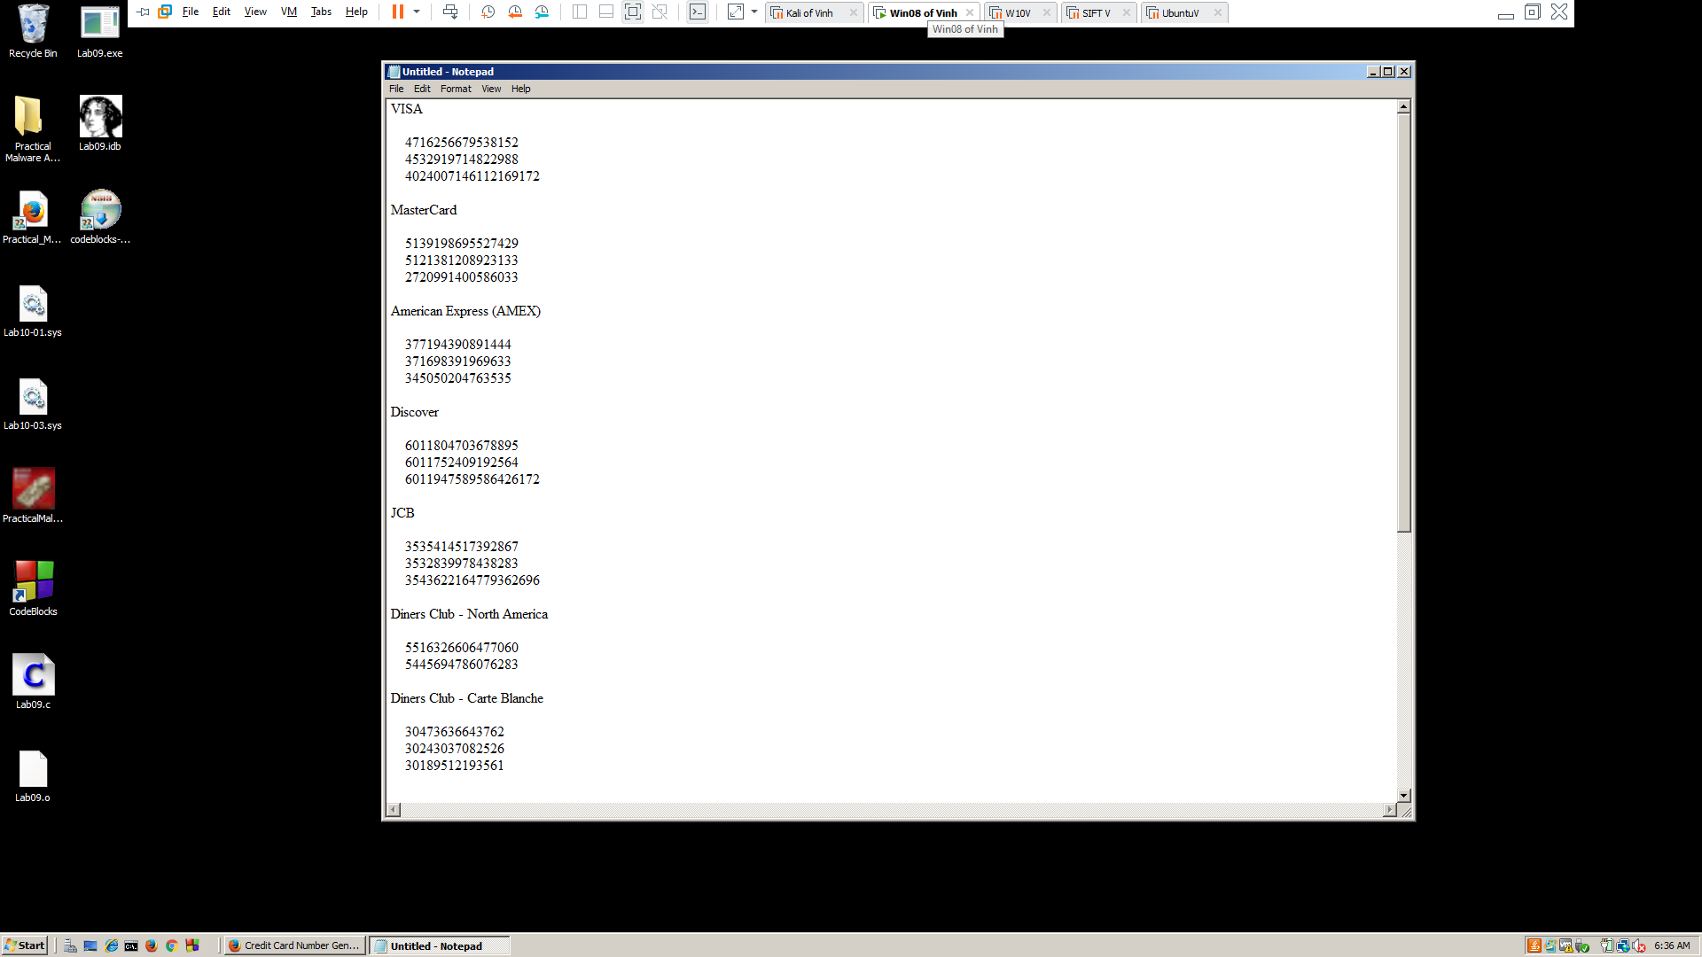

* Create user by net user in cmd

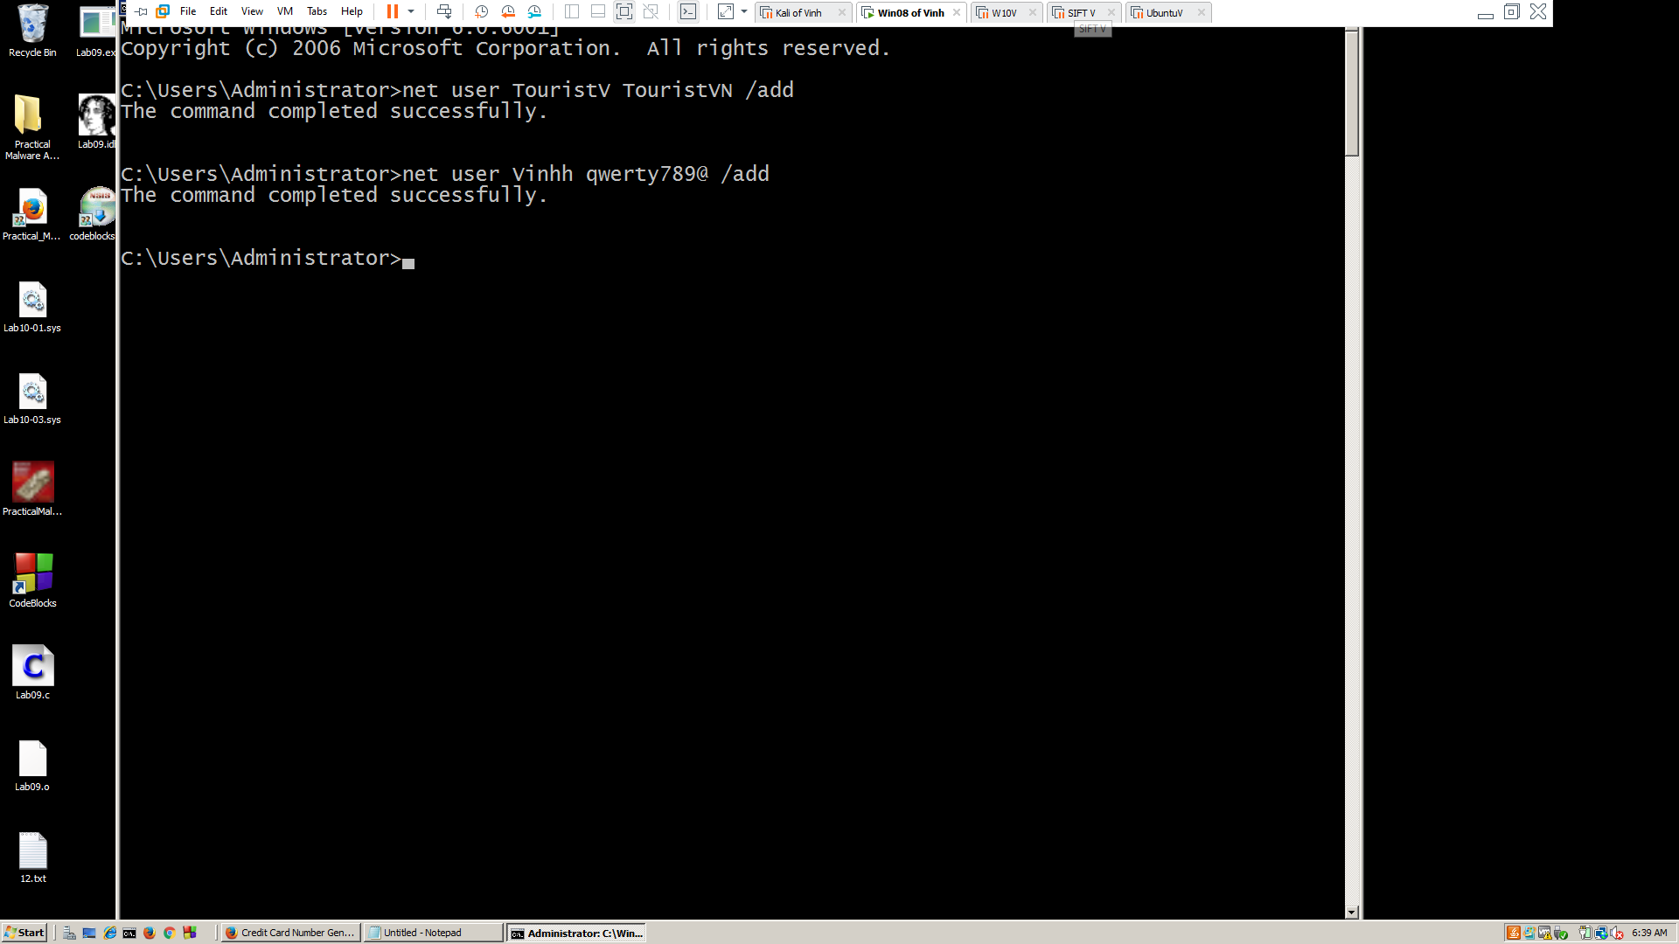

**- Acquiring a RAM Image with FTK Imager**

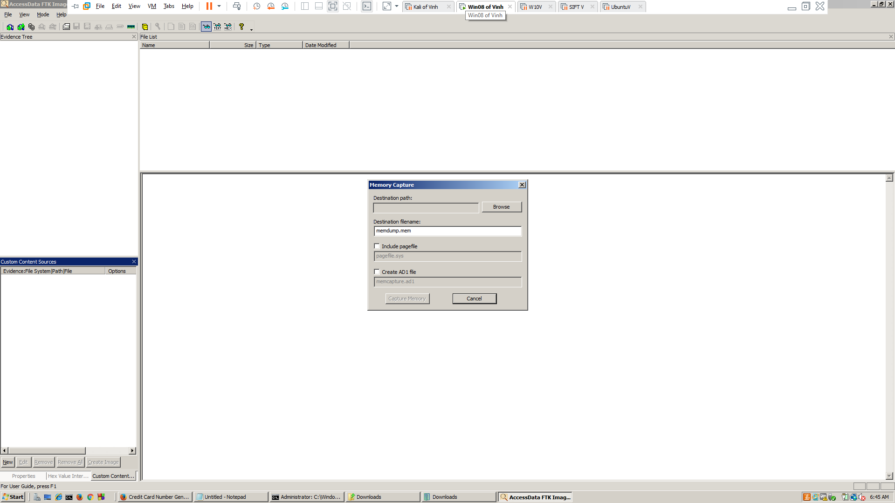 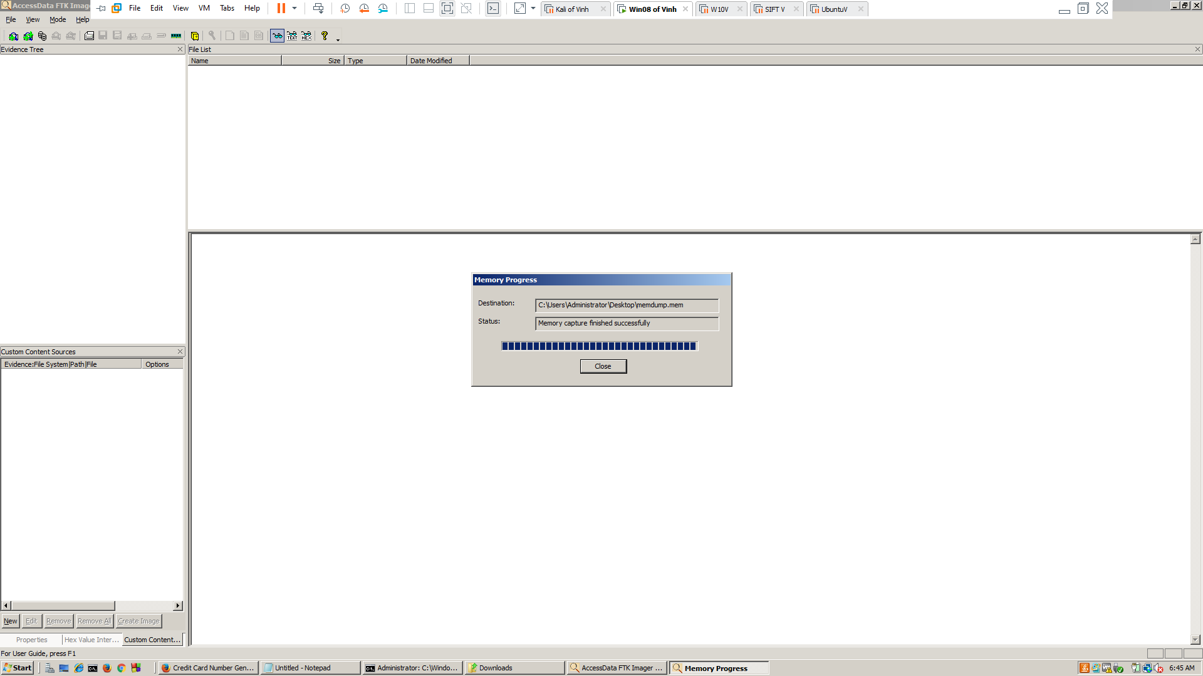

**-** Send file **memdump.mem** to Kali machine

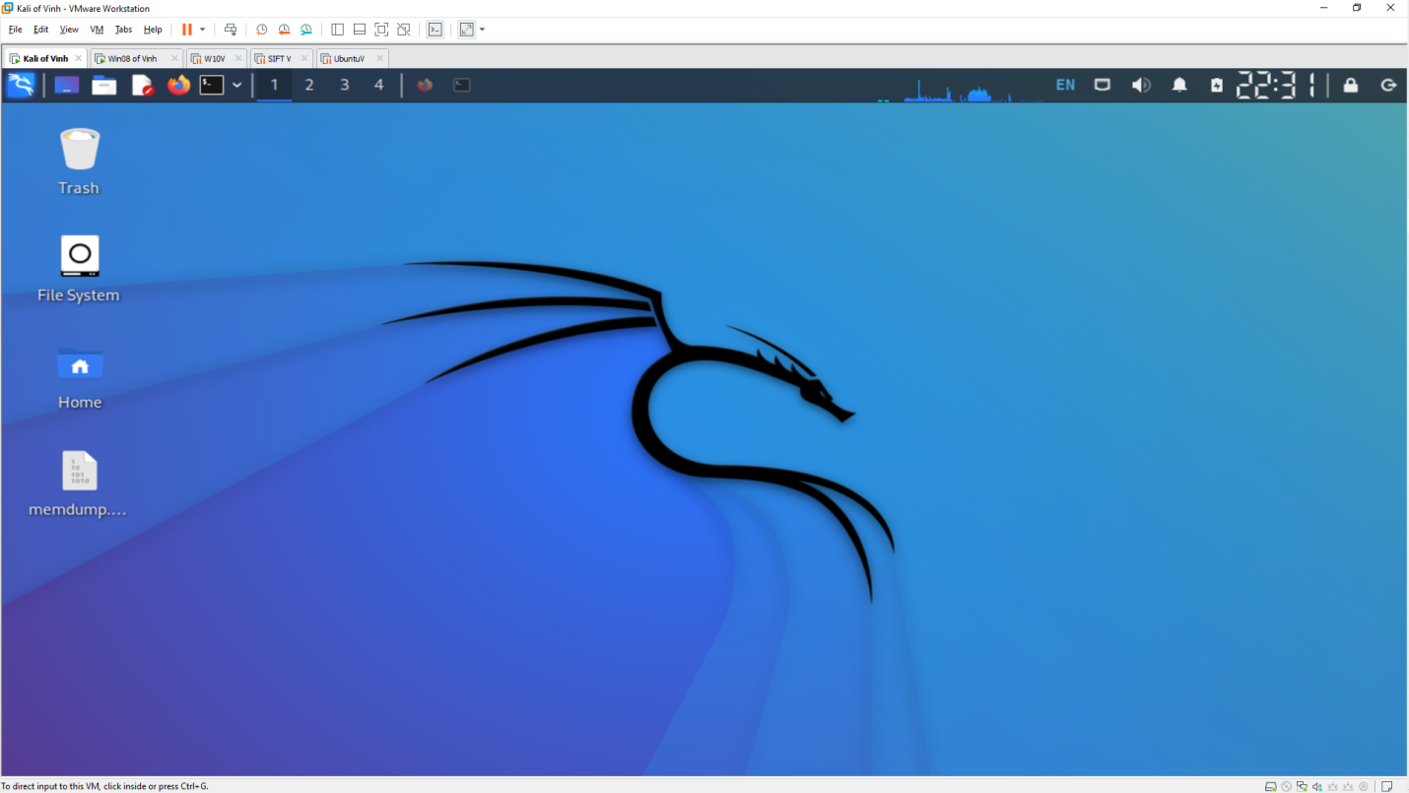

- Bulk Extractor

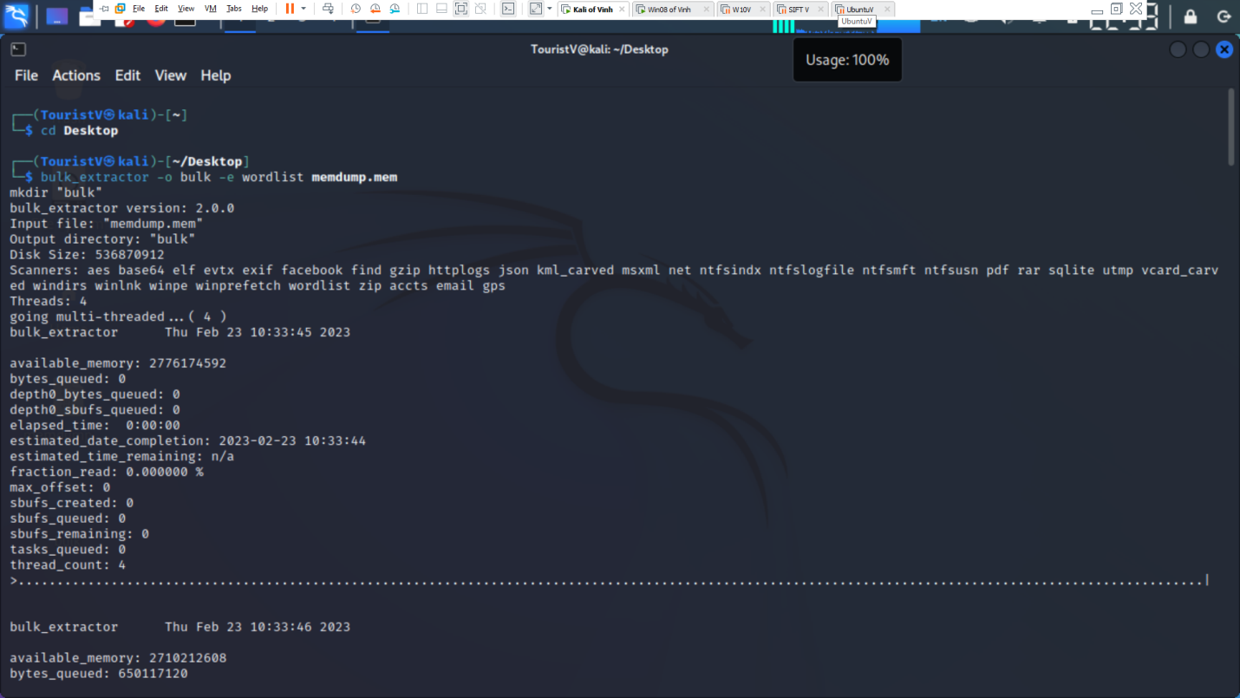 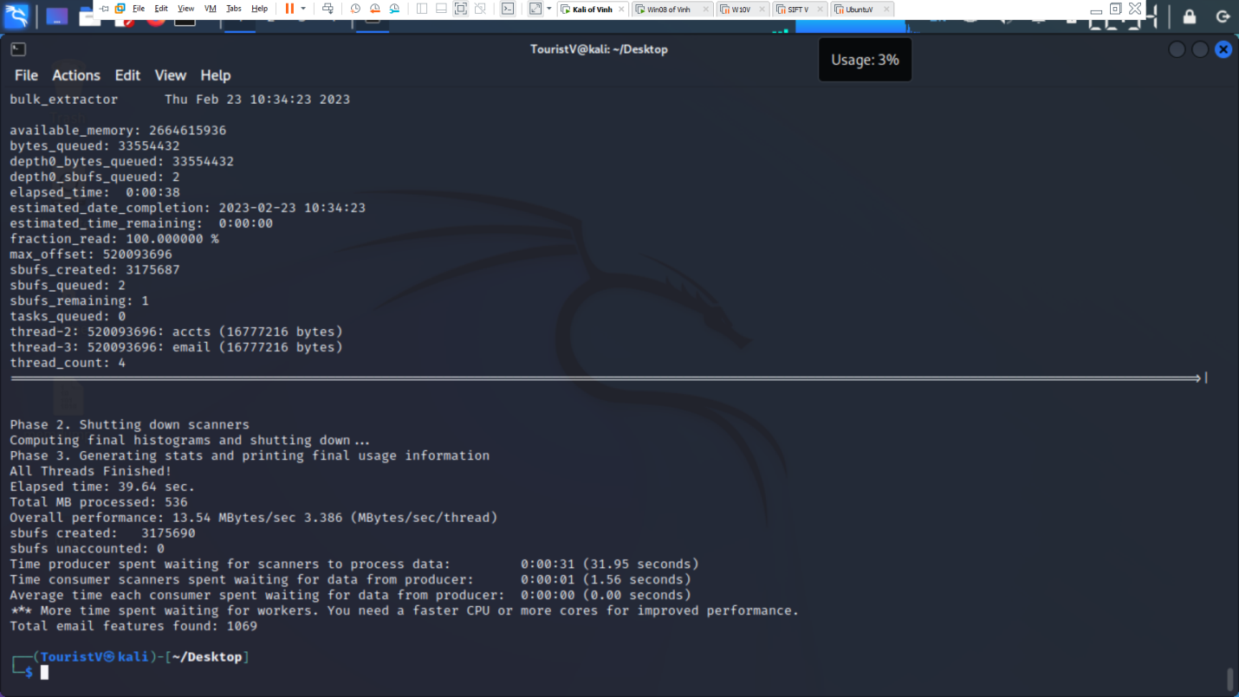 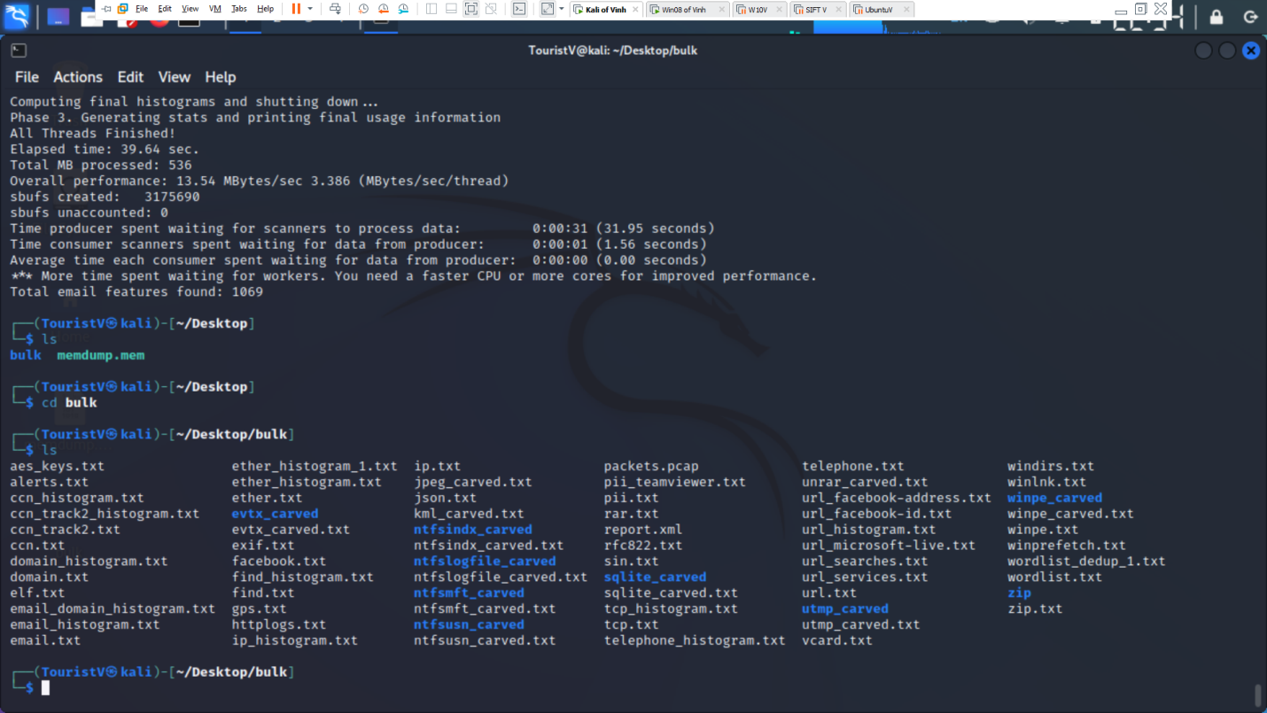

- check domain_histogram.txt

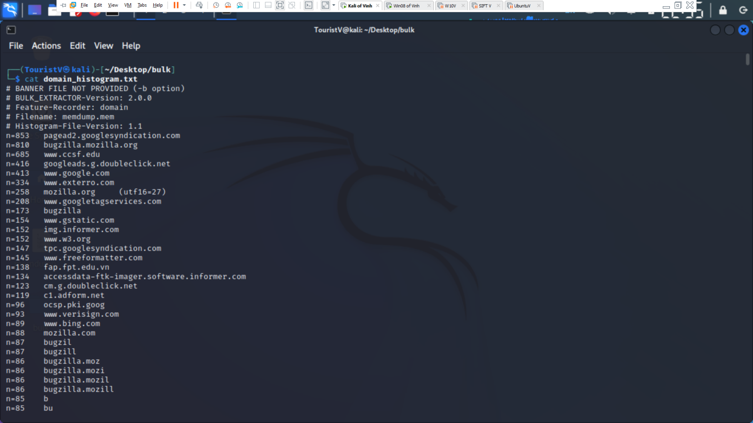

- check telephone_histogram.txt

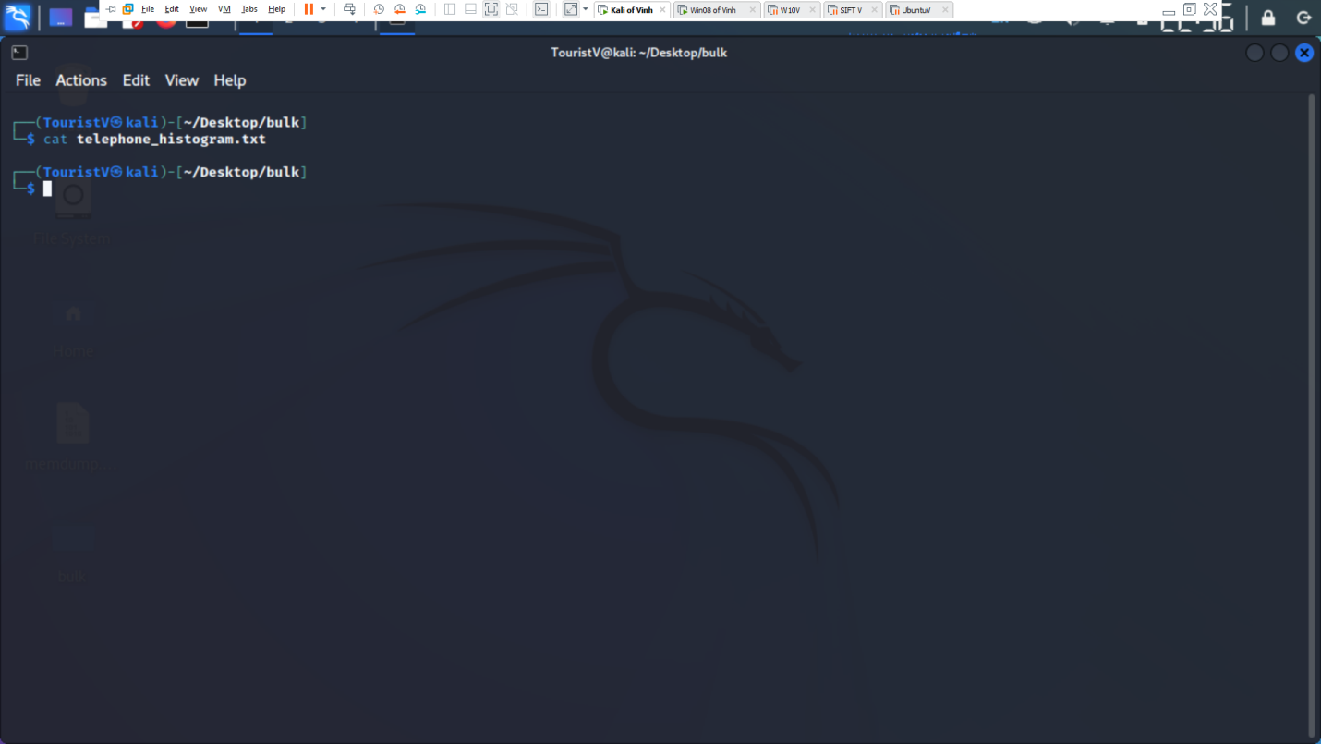

- check cnn_histogram.txt

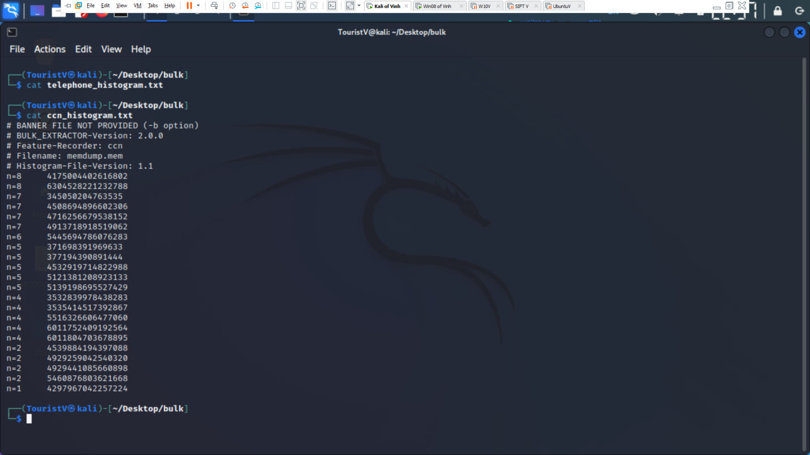

- check wordlist

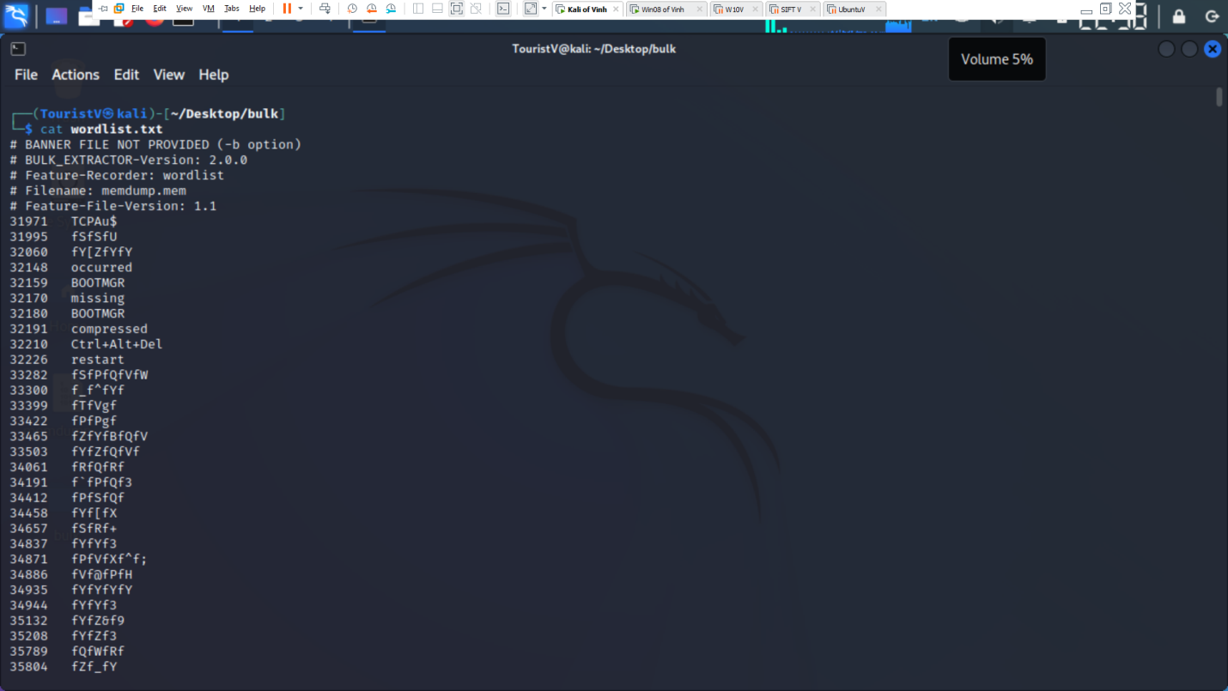 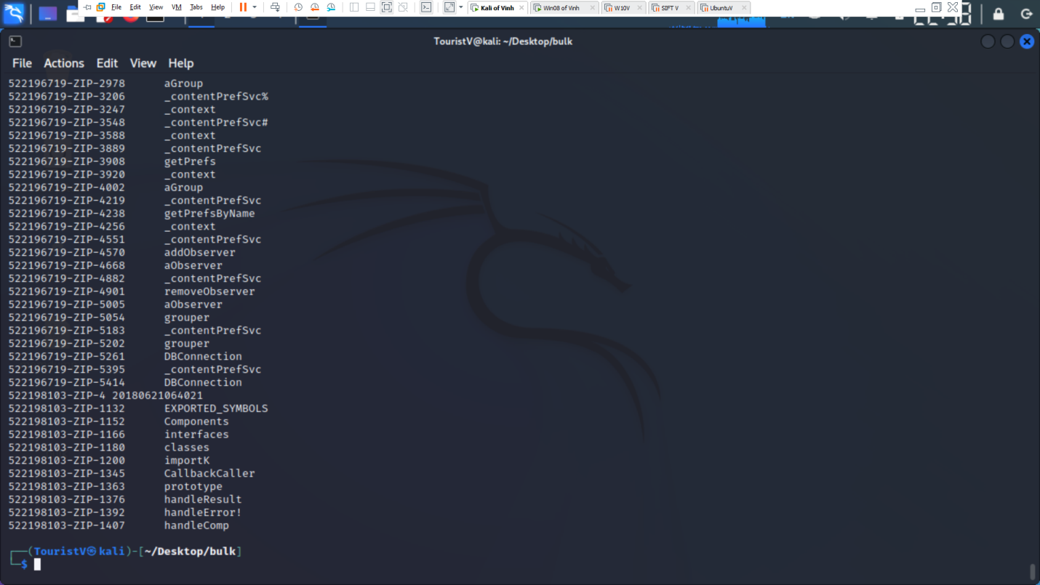

- check email

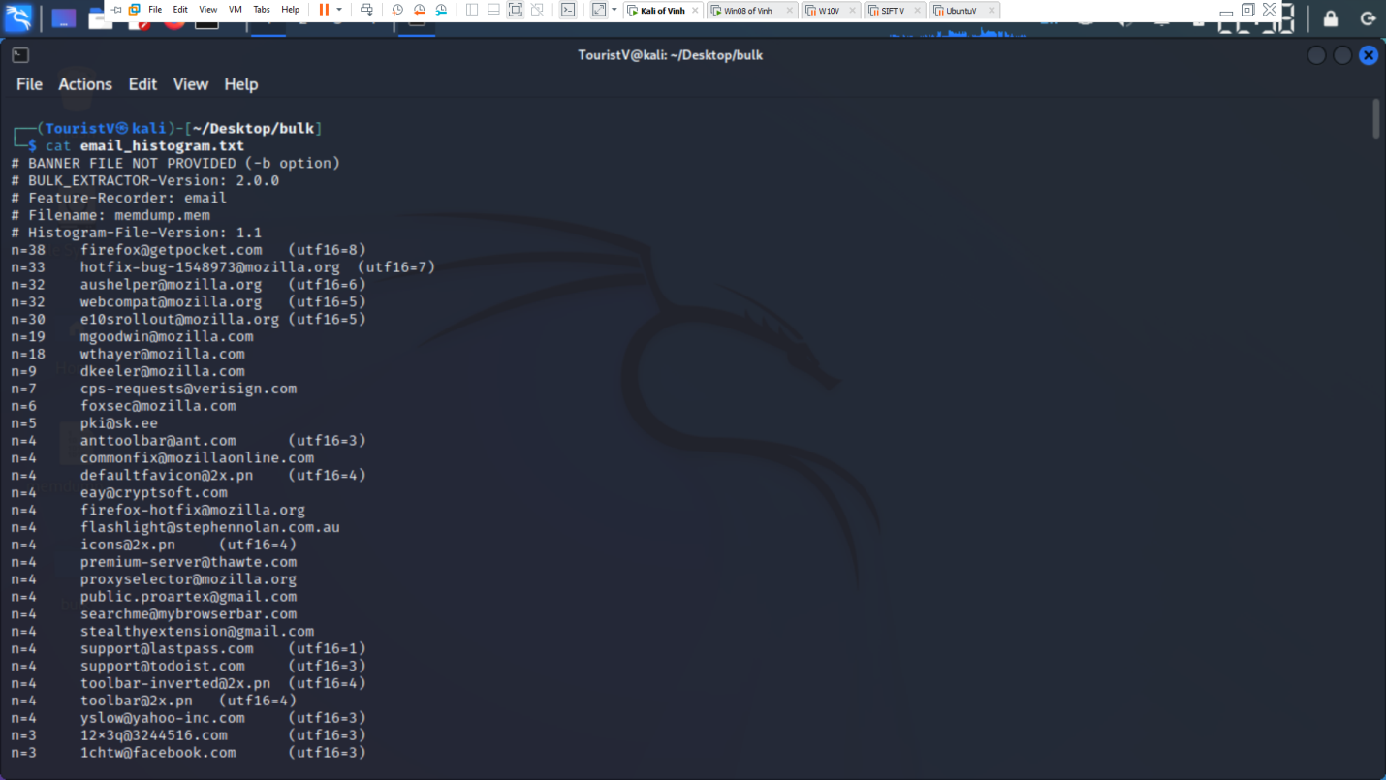

- Analyze Image RAM with Volatility

Command: volatility imageinfo -f /home/TouristV/Desktop/memdump2.mem

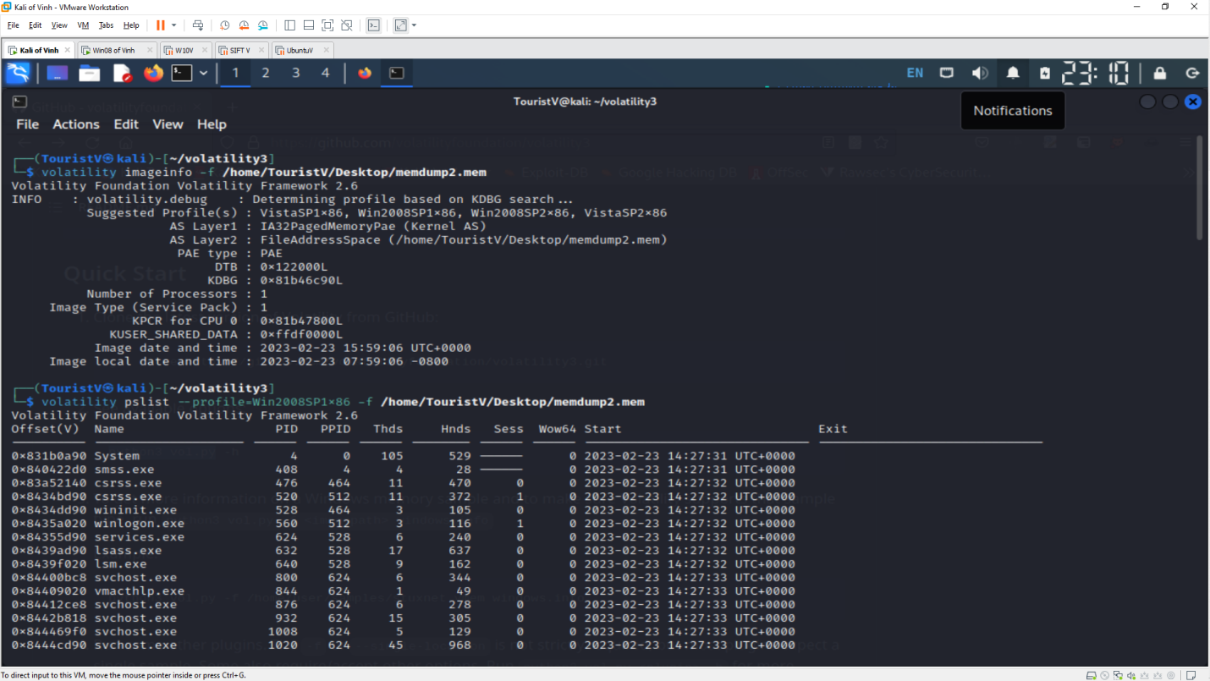

- Running processes

Command: volatility pslist --profile=Win2008SP1x86 -f /home/TouristV/Desktop/memdump2.mem

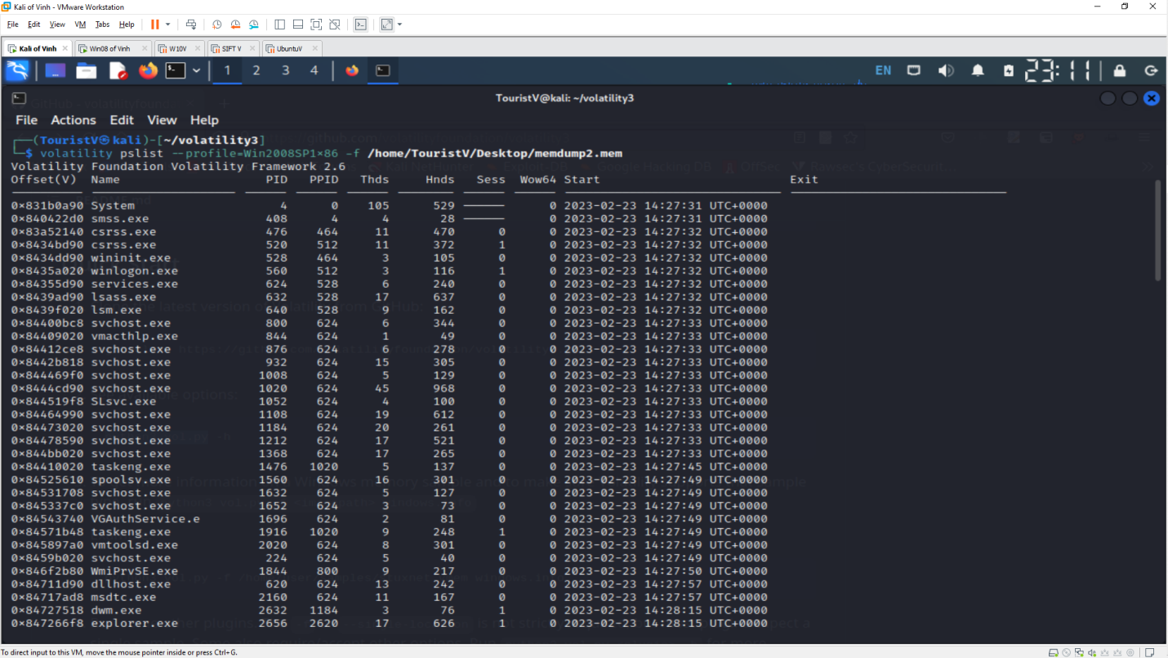

- Console Command:

Command: volatility consoles --profile=Win2008SP1x86 -f /home/TouristV/Desktop/memdump2.mem

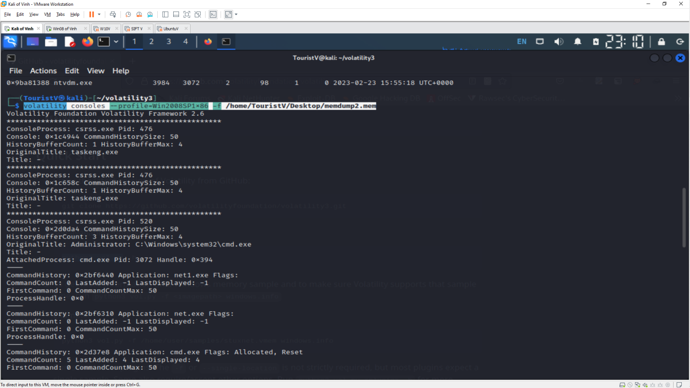

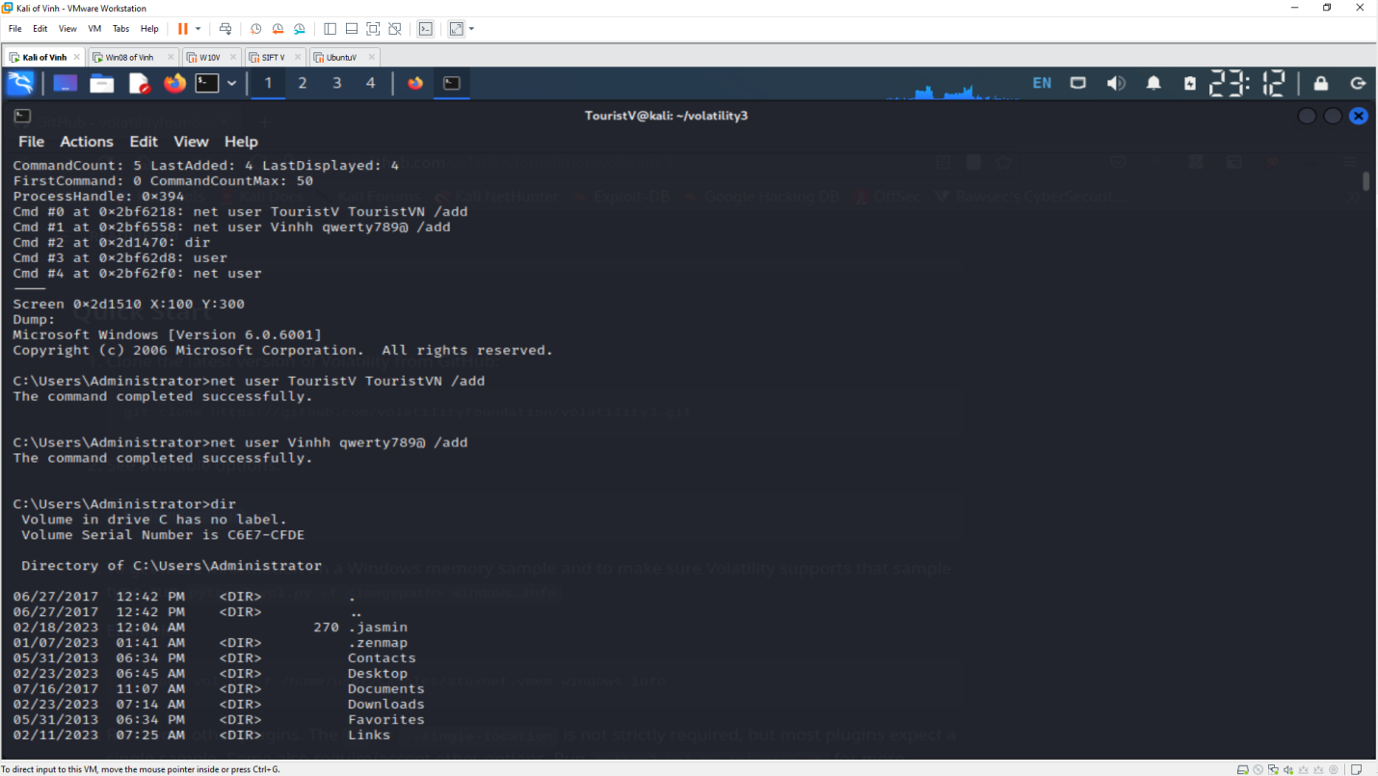

- Services:

Command: volatility svcscan --profile=Win2008SP1x86 -f /home/TouristV/Desktop/memdump2.mem

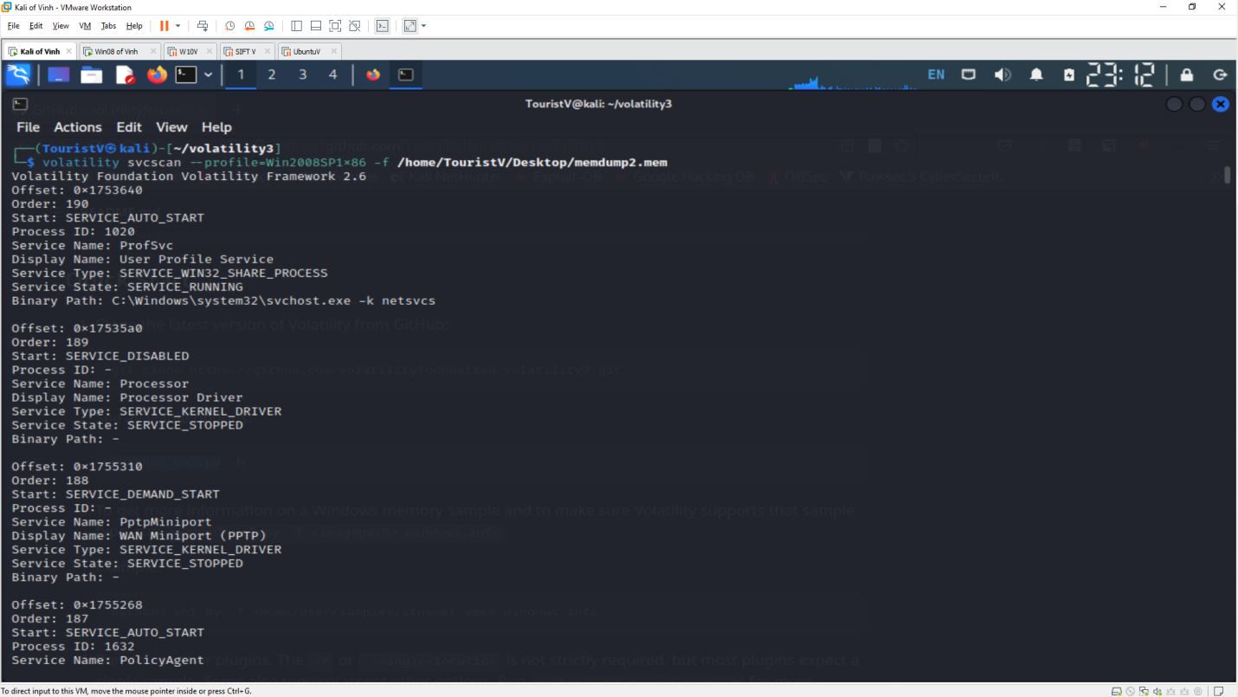

- Registry Hives:

Command: volatility hivelist --profile=Win2008SP1x86 -f /home/TouristV/Desktop/memdump.mem

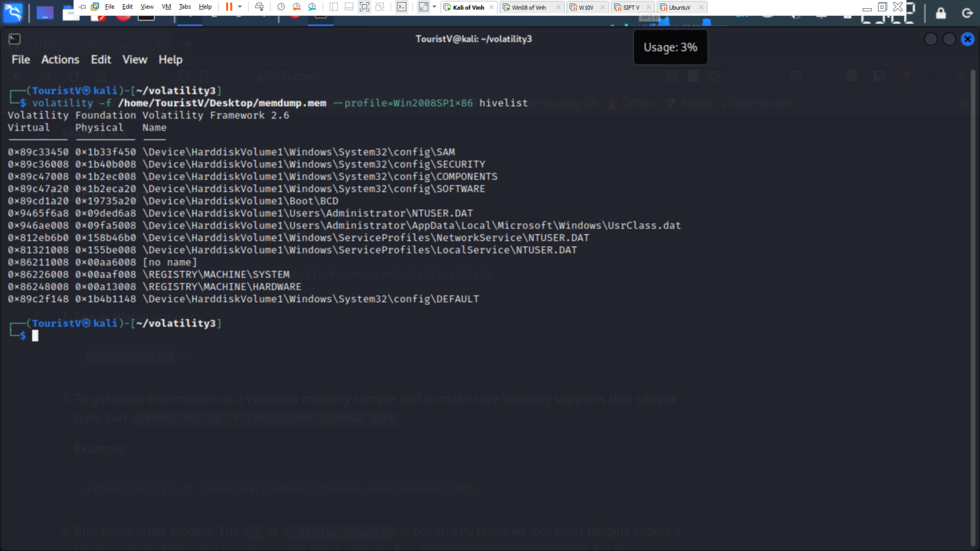

- Password hash:

Command: volatility hashdump --profile=Win2008SP1x86 -f /home/TouristV/Desktop/memdump.mem -y 0x86226008 -s 0x89c33450 > pass.txt

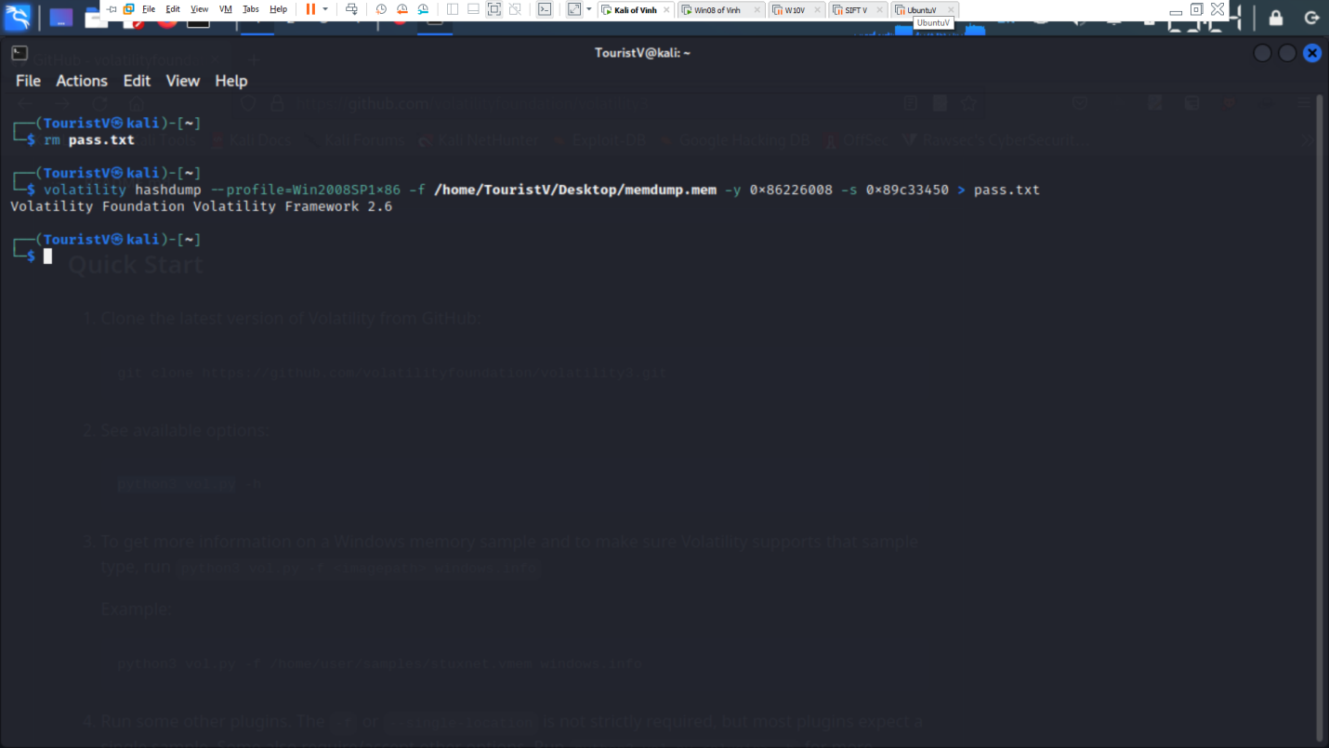 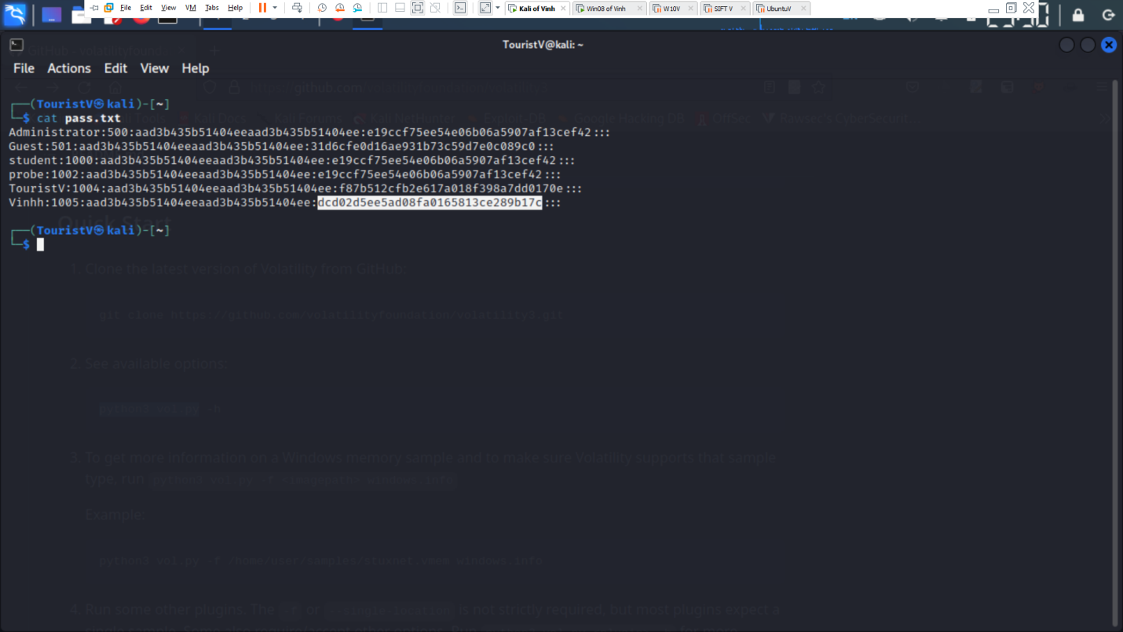

- Crack password

